Our Team
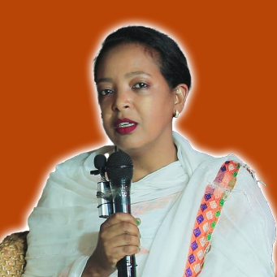
[YEMISRACH TSEGAW]
Position/Role: [FOUNDER & PRODUCTION MANAGER]
6 years of experience in [ TV SHOW DIRECTING & EVENTS ORGANIZING]
Worked as a director and production manager in [ TV SHOWS] including [Event organizing]
Strengths: [Teamwork, leadership, creativity, problem-solving, etc.]
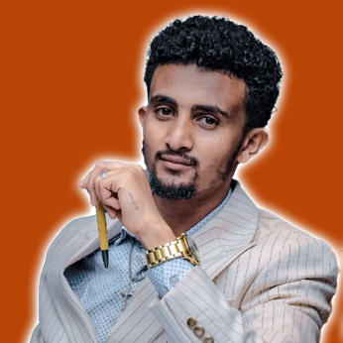
[YONATAN WORKU]
Position/Role: [G/MANAGER / CINEMATOGRAPHER & Editor]
Certified by [TOM FILM ACADAMY] in [FILM MAKING] [MUYALOGY ACADAMY] in [GRAHICS DESIGN & DIGITAL MARKETING]
[Other relevant certifications] TOT in ADVOCACY / RELIGIOUS COURSE
Skills & Expertise: CINEMA / DSLR / MIRRORLESS CAMERA / LIGHTS / SOUND EQUIPMENTS AND GRIPS
Skilled in [Software/Tools] ADOBE PREMIERE PRO / ADOBE AFTER EFFECT / ADOBE ILLUSTRATOR / ADOBE PHOTOSHOP / CANVA
4 years of experience in [ FILM MAKING & VIDEO EDITING]
Worked as a director in [ TV SHOWS] including [Event organizing]
Strengths: [Teamwork, leadership, creativity, problem-solving, etc.]
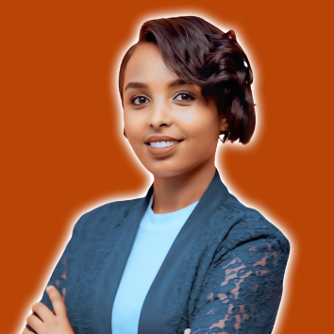
[ BETELHEM ASMAMAW ]
Position/Role: [ACTOR /SCRIPTWRITER/ DIRECTOR]
Winner @ Best Actress – 42nd Montreal World Film Festival (CANADA), Nominee @ Best Promising Actor Africa Movie Academy Awards (AMAA), NomineeJerusalem Film Festival INTERNATIONAL CRITICAL ACCLAIM
Skills & Expertise: ACTING / SCREEN PLAY / CONTENT CREATION
Skilled in [Software/Tools] CANVA FADE IN /ADOBE PHOTOSHOP
8 years of experience in [ FILM MAKING Directing & Event Organizing ]
Strengths: [CREATIVITY ,Teamwork, leadership, creativity, problem-solving, etc.]

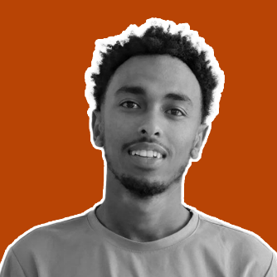
[ SEAD HASSEN]
Position/Role: [VFX ARTIST /MOTION DESIGNER / EDITOR]
Certified by [TOM FILM ACADAMY] in [FILM MAKING]
Skills & Expertise: CINEMA / DSLR / MIRRORLESS CAMERA / LIGHTS / SOUND EQUIPMENTS AND GRIPS
Skilled in [Software/Tools] ADOBE PREMIERE PRO / ADOBE AFTER EFFECT / ADOBE ILLUSTRATOR / ADOBE PHOTOSHOP / BLENDER
4 years of experience in [ FILM MAKING & VIDEO EDITING & MOTION DESIGN ]
Worked as a VFX ARTIST / CINEMATOGRAPHER / VIDEO EDITOR
Strengths: [Teamwork, leadership, creativity, problem-solving, etc.]

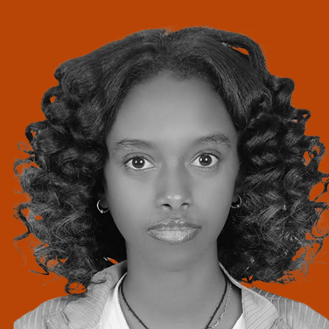
[ EYERUSALEM GEZAHENG]
Position/Role: [WEB DEVELEOPER / CONTENT CREATOR / DIGITAL MARKETER]
BACHELOR DEGREE [BAHIRDAR UNIVERSITY] in [SOFTWARE ENGINEERING]
Skills & Expertise: PYTHON / JAVASCRIPT / PHP
Skilled in [Software/Tools] ADOBE PREMIERE PRO / CAPCUT / ADOBE PHOTOSHOP / CANVA /FIGMA FADE IN
2 years of experience in [ DIGITAL MARKETING / SOCIAL MEDIA MANAGMENT /WEB DEVELOPMENT]
Worked as a WEB DEVELOPER / DIGITAL MARKETOR / CONTENT CREATOR / GRAPHICS DESIGNER
Strengths: [Teamwork,creativity, problem-solving, etc.]


[ MINTESNOT DESALENG]
Position/Role: [CINEMATOGRAPHER / GRAPHICS DESIGNER]
Certified by [TOM FILM ACADAMY] in [FILM MAKING]
Skills & Expertise: CAMCODER / DSLR / MIRRORLESS CAMERA / LIGHTS / SOUND EQUIPMENTS AND MAIN STREAM GRIPS
Skilled in [Software/Tools] ADOBE PREMIERE PRO / CAPCUT / ADOBE PHOTOSHOP / CANVA
4 years of experience in [ FILM MAKING & VIDEO EDITING]
Worked as a CREATIVE DIRECTOR / PRODUCTION MANAGER / LIVE DIRECTOR / CAMERA MAN
Strengths: [Teamwork,creativity, problem-solving, etc.

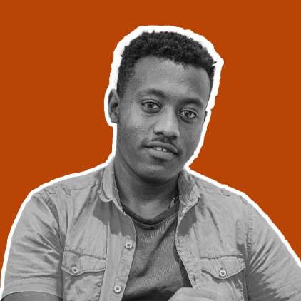
[NATNAEL WORKU]
Position/Role: PHOTOGRAPHER / EDITOR]
Certified by [TOM FILM ACADAMY] in [FILM MAKING]
Skills & Expertise: DSLR / MIRRORLESS CAMERA / LIGHTS
Skilled in [Software/Tools] ADOBE PREMIERE PRO / CAPCUT / ADOBE PHOTOSHOP / CANVA
4 years of experience in [ PHOTOGRAPHY & PHOTO EDITING]
Worked as a PHOTOGRAPHER / VIDEOGRAPHER / PHOTO EDITOR
Strengths: [ Teamwork, creativity, problem-solving, etc.]

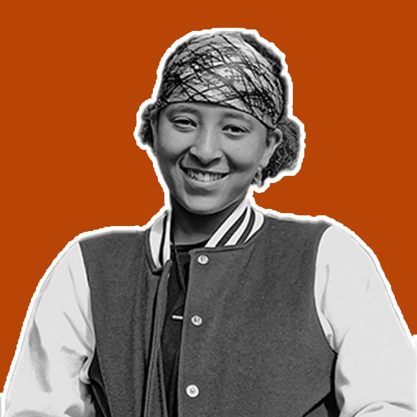
[ BETELHEM ZEMECHA]
Position/Role: [Script Writer / Director]
Certified by [TOM FILM ACADAMY] in [FILM MAKING]
Skills & Expertise: CINEMA / DSLR / MIRRORLESS CAMERA
Skilled in [Software/Tools] FADE IN / MS WORD / CAPCUT /ADOBE PHOTOSHOP
4 years of experience in [ FILM MAKING & SCRIPT WRITING / CONTENT CREATION]
Worked as a SCRIPT WRITER / PRODUCTION MANAGER / DIRECTOR
Strengths: [Teamwork, leadership, creativity, problem-solving, etc.]

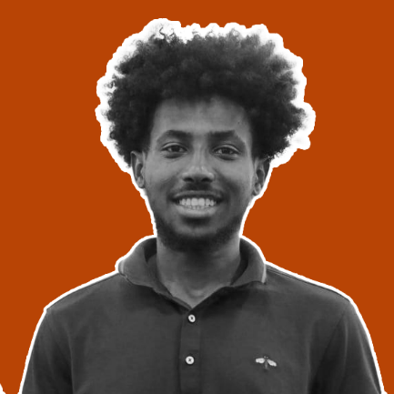
[ Natnael Gezaheng]
Position/Role: [CINEMATOGRAPHER / SET DESIGNER]
Certified by [TOM FILM ACADAMY] in [FILM MAKING]
Skills & Expertise: CINEMA / DSLR / MIRRORLESS CAMERA
Skilled in [Software/Tools] / CAPCUT /ADOBE PHOTOSHOP /ADOBE PREMIERE PRO
4 years of experience in [ FILM MAKING & PHOTOGRAPHY]
Worked as a PHOTOGRAPHER / CINEMATOGRAPHER / PHOTO EDITOR
Strengths: [Teamwork, leadership, creativity, problem-solving, etc.]

